Let’s get engaged!! What does your ideal partner look like? Talk with us and let’s create the perfect marriage between your brand and JustMarried

The Best of JustMarried: As Deb says it is good to hit them over the head/repeat so certain messages sink in I’ve but some one-liners here that you might want to squeeze in here or there. This is your own word doc copy if you want to highlight certain ones you favor, think are most important to squeeze in per sponsor.
- .Love is what the world needs now!

- The greatest civil rights win of this century ushered in societal inclusivity and dignity most never imagined possible.

- These stores feature couples from a variety of age, race, religion, gender identity, political and socio-economic backgrounds.

- These courageous couples didn’t go into it to be activists, they went into it to be together.

- This one-of-a-kind historical collection encompasses an unparalleled, curated archive of images, articles and personal narratives – triumphant stories while bringing to bear the current stories unfolding today

- We have only three Platinum Sponsorships and believe Absolut would make the perfect partner considering the brand’s long history supporting the LGBTQ+. For the average cost of 6 single page national ads, Absolut can get over a year of PR and give something tangible and necessary for the LGBTQ+ community. Plus your long history makes for seamless placement into the Docuseries script.

- These are stories of love and courage, at a time when we may need them the most.

- While the majority of the Platinum Sponsorship can be split over 2024 & 2025 budgets, if Culture or another department has funds this year, we can hold one of the three spots for your brand. This will help us speedup finishing the book and podcast and continue filming more interviews for the Docuseries.

- Where will the docuseries stream? We are in the process of looking for a production partner. That partner will determine mostly likely where the docuseries ends up, but we are aiming for Netflix, Amazon, HBO/Hulu, something with a big audience. There are stories from a good number of celebrities that will we believe will draw a large audience on their own.

- It is a historical collection that resonates, educates and inspires future generations to understand why people fought for our rights— and how easily those rights can be lost.

- ‘Love Is The Most Powerful Force In The Universe- It Can And Does Transform Everything’ Jack Baker + Michael McConnell {The First Legally Wed LGBTQ+ Couple in the US, this quote will be at the front of the book}

Here is some up to date info for calls with sponsors:

- 7.2% of US adults identify as LGBTQ
- Globally, LGBTQ people hold an estimated $3.9 trillion in purchasing power, according to investment adviser LGBT Capital. A survey by the consulting firm Edelman found that Americans are twice as likely to support pro-LGBTQ brands and 4.5 times as likely to work for them.
- LGBTQ+ consumers in the US $1.4 trillion in spending power Bloomgerg 10/6/23

- LGBTQ purchasing power is about to explode. Brands that understand how to connect authentically with younger generations will rise to the top in coming years. Nearly 18 percent of Generation Z, the group of people born between 1997 and 2012, identify as not heterosexual, according to survey data from research firm Ipsos that surveyed 19,000 respondents from 27 countries. Gen Z’s purchasing power is small now, but their earnings will balloon to $33 trillion by 2030, accounting for a quarter of all global income.
- 70% of marketers reported that content incorporating visuals assets performed better than those without. Contently & Libris
- 74% of B2B marketers created long-form written content in the past year. CMI & MarketingProfs
- The longevity of this project is important. Print advertisements have a general shelf life of one month. WebFX gives an average national magazine advertising cost of $250,000 to run a single full-page ad.
- Advertising in a national newspaper costs approximately $100,000 at a minimum. At the higher end, you could pay over $1.4 million /WebFX
- An ad in People $445,600
- InStyle $225,00
Content Marketing is a lot of work. We are doing it for you
Benefits of Content Marketing
- Consumer Engagement
- Brand Awareness
- Longer ROI Than Paid –the traffic and leads it can generate can last years
- Builds Community Trust

2022 Edelman Trust Barometer Special Report: In Brands We Trust?
- 69% Consumers say they want a brand to express their values
- 81% Must be able to trust a brand to do what is right (18-54) 79% (55+)
- Trusted brands act on their words by making a promise and making a difference. If a brand publicly supports and demonstrates a commitment to expanding and protecting LGBTQ+rights, Americans are 2x more likely to buy or use the brand
- 74% of consumers use one or more advertising avoidance strategies
- 63% 18-24 trust what influencers say about brands much more than what brands say about themselves in their advertising
- 62% consumers buy from a brand that actively supports or speaks out on an issue tha
- 75% will will engage in each behavior on behalf of a trusted brand even if another brand suddenly becomes hot and trendy
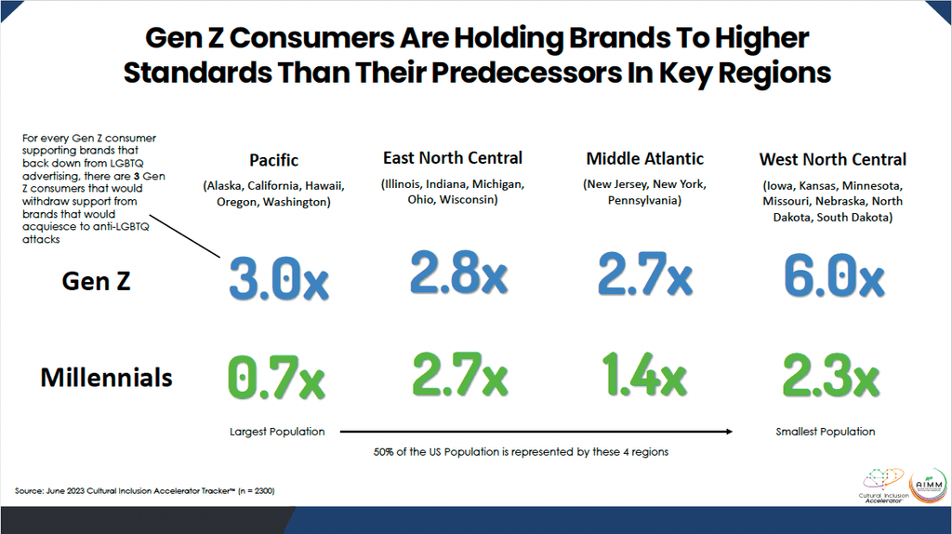
As seen in Q Digital ills above and info below:

1. Most Americans support advertising that includes LGBTQ+ people
- Americans are 2x more likely to buy or use a brand if the brand publicly supports and demonstrates a commitment to expanding and protecting LGBTQ+ rights, according to a new study by GLAAD and Edelman Trust Institute.
- A 91% supermajority of non-LGBTQ+ Americans agree that LGBTQ+ people should have the freedom to live their lives and not be discriminated against, according to GLAAD’s Advertising Report.
- 75% of non-LGBTQ+ adults feel comfortable seeing LGBTQ+ people in advertisements.
- 18-34-year-olds are nearly twice as likely than the general population to say that protecting the rights of the LGBTQ+ community should be a top priority for brands when it comes to allocating money and resources.

2. Most brands stood by the LGBTQ+ community with vocal support and continued program sponsorships, and they faired well.
Interpride, which represents 375 global Pride organizations, reports that sponsorships were up 20% YOY. Studies found that brands willing to stand by LGBTQ+ people amid criticism can help increase consumers’ opinions, trust, and interest in purchasing from them.
3. Brands that gave in to anti-LGBTQ+ sentiment lost support with both LGBTQ+ people and consumers overall.
A recent article in Fast Company titled “Bud Light poured decades of LGBTQ allyship down the drain – and now everyone’s mad” detailed the fallout from the “culture-war panic,” saying that “the beer marketer has possibly thrown out decades of goodwill and soured the audience of drinkers it needs to woo.”
4. Research from the Association of National Advertisers shows standing with the community and not backing down wins more consumers.
The study found that for every consumer that supports brands that stop their LGBTQ+ advertising efforts, there are 1.8 consumers that would withdraw support from those brands for acquiescing to anti-LGBTQ+ attacks. This net loss grows exponentially with GenZ and Millennial consumers.
Sponsorship pitch:
More valuable than getting an impression is making one
JustMarried’s Docuseries, Serialized Podcast and Coffee-Table Book celebrates the 10th anniversary of marriage equality in the US, one of the most important civil rights wins of the past 100 years. This project is the holy grail of content for those looking to bond at the highest level with this community. Authenticity is increasingly important to consumers. Inclusive brands that support in a way that actually drives change and supports LGBTQ+ causes in the process is the sure way to be authentic.
JustMarried’s authentic and original stories simultaneously underscore that love can win while bringing attention to the fact that the struggle is ongoing
The unique combination of :
- Emotional, one of the most important civil rights win of this century
- Powerful /intimate storytelling is from true LGBTQ+ heroes and A list influencers
make this a rare, one-of-a-kind content marketing partnership program

